1. What is Linq?

LINQ stands for Language-Integrated Query and is a powerful query language introduced with .NET 3.5 & Visual Studio 2008. You can use LINQ with C# or VB to query different types of data sources such as SQL, XML, In memory objects, etc.

LINQ provides a simple but very effective way to manipulate data from different data sources such as databases, XML files, or with a simple list of in-memory data.

1. What are the different things required to write a LINQ Query?

In order to write a LINQ query, we need the following three things

* Data Source (In-Memory Objects, SQL Server, XML Document, etc.)
* Query
* Execution of the Query

1. What is a Query?

A query is nothing but a set of instructions that are applied to a data source (i.e. In-Memory Objects, SQL Server, XML Document, etc) to perform certain operations (i.e. CRUD operations) and then tells the shape of the output from that query. That means the query is not responsible for what will be the output rather it is responsible for the shape of the output. This means what is going to return from that query whether it is going to return a particular value, a particular list, or an object. Each query is a combination of three things. They are as follows:

* Initialization (to work with a particular data source)
* Condition (where, filter, sorting condition)
* Selection (single selection, group selection, or joining)

1. What are the different ways to write a LINQ query?

We can write the LINQ query in three different ways. They are as follows

* Query Syntax
* Method Syntax
* Mixed Syntax (Query + Method)

Note: From the performance point of view there is no difference between the above three approaches. So, which you need to use, totally depends on your personal preference. But the point that you need to keep in mind is, behind the scene, the LINQ queries written using query syntax are translated into their lambda expressions before they are compiled.

LINQ Query Syntax:

This is one of the easy ways to write complex LINQ queries in an easy and readable format. The syntax for this type of query is very much similar to SQL Query. If you are familiar with SQL queries then it is going to be easy for you to write LINQ queries using this query syntax. The syntax is given below.

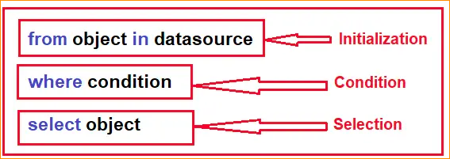

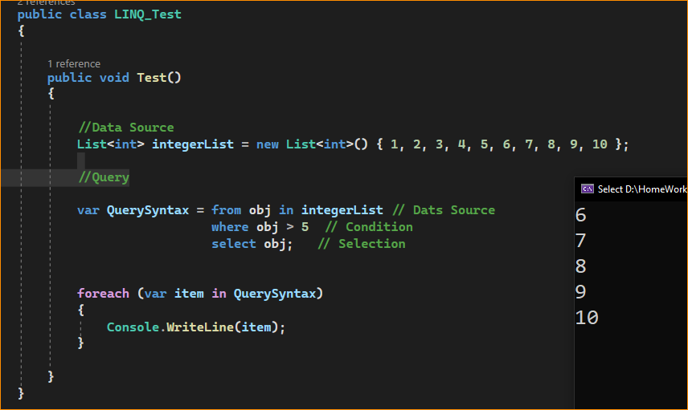

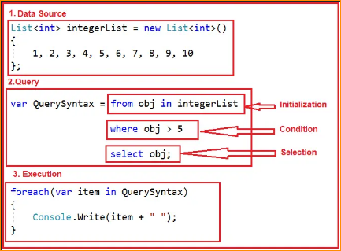

LINQ Method Syntax:

Method syntax becomes most popular now a day to writing LINQ queries. It uses a lambda expression to define the condition for the query. Method syntaxes are easy to write simple queries to perform read-write operations on a particular data source. But for complex queries Method syntaxes are a little hard to write as compared to query syntax. In this approach, the LINQ query is written by using multiple methods by combining them with a dot (.) i.e. Method Chaining. The Syntax is given below:

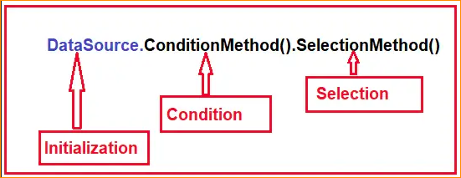

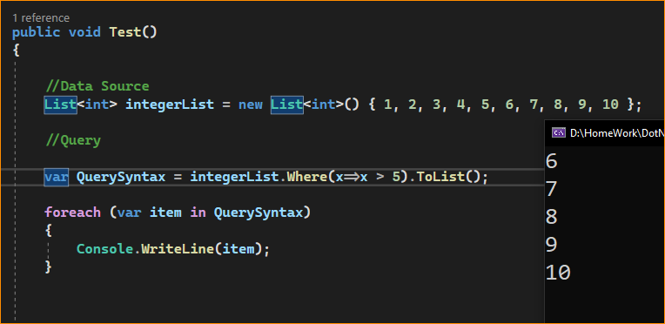

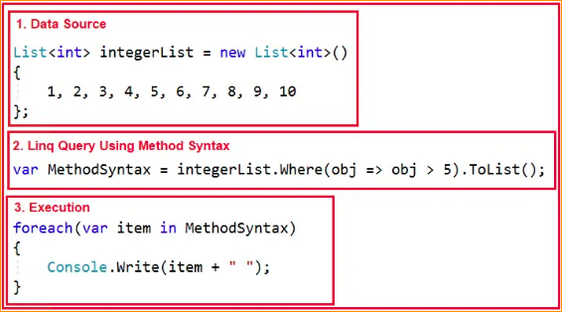

LINQ Mixed Syntax:

This is the combination of both Query and Method syntax. The syntax is given below.

